# Fact Sheet: Access Energy Product Reference Data

February 2025

This fact sheet is used to call the Get Generic Plans and Get Generic Plan Detail Product Reference Data (PRD) Application Programming Interfaces (API’s) to access generic energy plan data held by the AER and Victoria’s Department of Energy, Environment and Climate Action (DEECA). The AER is a designated data holder under the Competition and Consumer (Consumer Data Right) Rules 2020 and provides energy PRD for APIs.

To commence this process, the appropriate software is required to call the API. Calling or pasting the API URLs into your browser will return an error.

**Steps to run** **Get Generic Plans API:**

1. Retrieve the required retailer URI from the list published on the AER website - <https://www.aer.gov.au/documents/consumer-data-right-list-energy-retailer-base-uris-may-2024>
2. Replace the highlighted section of the URL with the URI selected in step 1.

GET <https://cdr.energymadeeasy.gov.au/agl/cds-au/v1/energy/plans>

1. 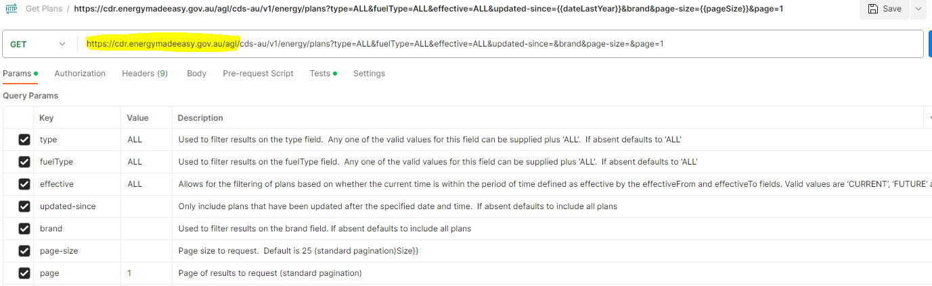Add any required query parameters as shown below. Additional information about query parameter keys can be located [here](https://consumerdatastandardsaustralia.github.io/standards/#get-generic-plans).
2. 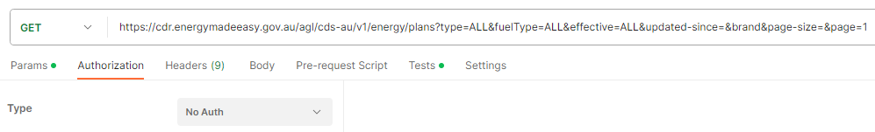Set Authorisation to ‘No Auth’ as this is a publicly available API
3. 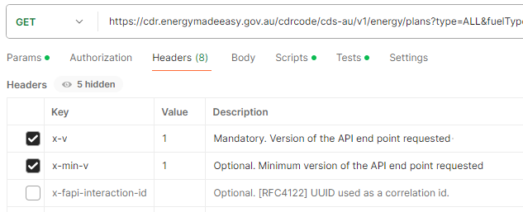Add any required header keys as shown below. Note that x-v is a mandatory key.  Additional information and header keys can be located [here](https://consumerdatastandardsaustralia.github.io/standards/#http-headers).

*\*Please note that the Get Generic Plans API remains in its initial version, even though the Get Generic Plan Detail API has reached Version 3. Plans available in Version 1 of the Get Generic Plans API will be displayed consistently across all available versions of the Get Generic Plan Detail API.*

**Steps to run Get Generic Plan Detail API:**

1. Retrieve the required plan ID from the list of plans returned in the Get Generic Plans API response
2. Use the same URL as for the Get Generic Plans API

GET <https://cdr.energymadeeasy.gov.au/agl/cds-au/v1/energy/plans>

1. 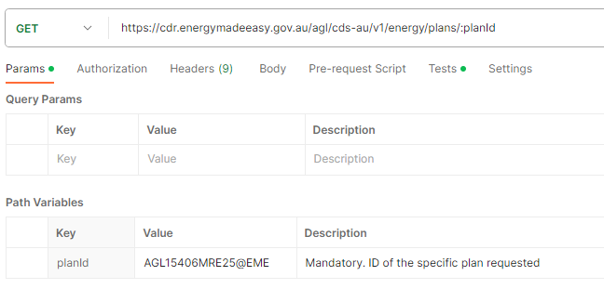Add the plan ID as a mandatory path variable as shown below or as a query parameter e.g. GET <https://cdr.energymadeeasy.gov.au/agl/cds-au/v1/energy/plans/AGL15406MRE25@EME>
2. Set Authorisation to ‘No Auth’ as this is a publicly available API
3. Set the mandatory key x-v to specify the required version when requesting the version endpoint.

*Please note that from 3rd March 2025, we will only be supporting Version 3 of the API For further details, please refer to the* [*Consumer Data Standards*](https://consumerdatastandardsaustralia.github.io/standards/#cdr-energy-api_get-generic-plan-detail)

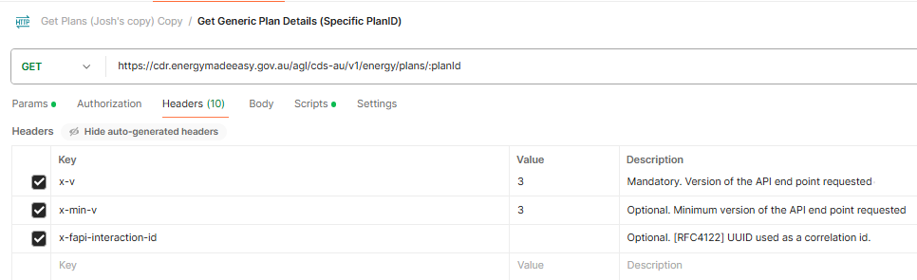

1. Add any required header keys as shown below. Additional information and header keys can be located [here](https://consumerdatastandardsaustralia.github.io/standards/#http-headers).

© Consumer Data Right 2025